**Zillow Style Guide for Tableau**

**Version: 1.0**

Updated: April 20, 2016

**CHART TYPES + VISUAL ANALYSIS**

Text Table/Highlight Table

The text table has two primary uses, depending on configuration. In the pure crosstab format, it is most useful for displaying detail at a specified granularity. Tableau text tables can only be 16 columns wide, and are often susceptible to double-scrollbars due to too much information. A table should only need to scroll in one direction, otherwise the user will be easily confused.

The default Tableau Text Table is somewhat unhelpful since it does not section off data in a very visible way. Formatting with borders or row bands can be an easy way to draw attention to changes in your dimensions.

For borders, you should use the light variants of the Zillow Text:

* #666666 (darker)
* #999999 (lighter)

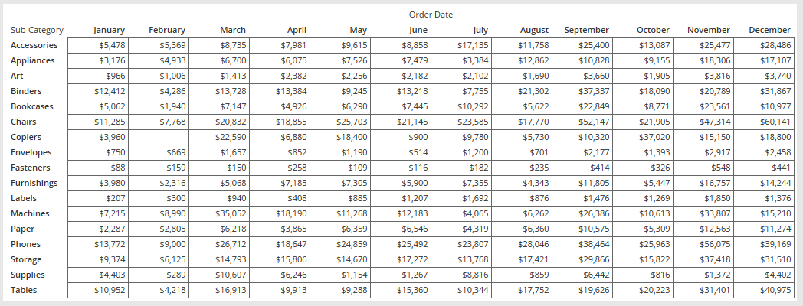

For row bands, start with the gray variants on Zillow Backgrounds, and experiment with colors if your design calls for it (you’ll know if it looks bad as soon as you do it):

* #ccccccc (light gray)
* #dddddd (very light gray )
* #eeeeee (lightest gray)
* #f8fbff (very pale white, blue tint)
* #eceffc (light grayish blue)
* #edf8d9 (light grayish green)
* #feffdf (very pale yellow)

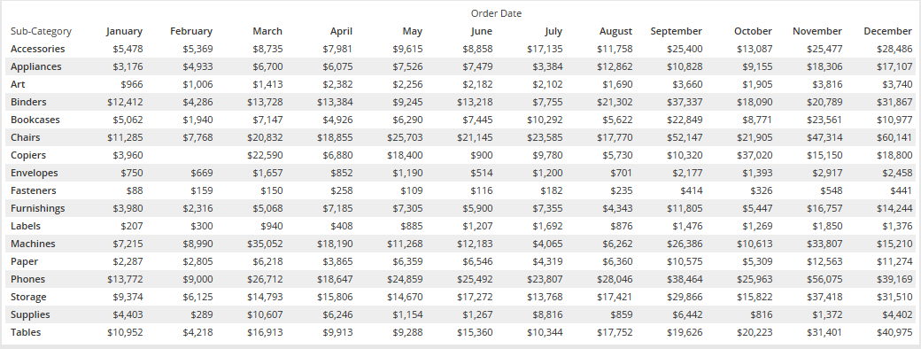

Or you can use both at the same time – although this make the table quite busy.

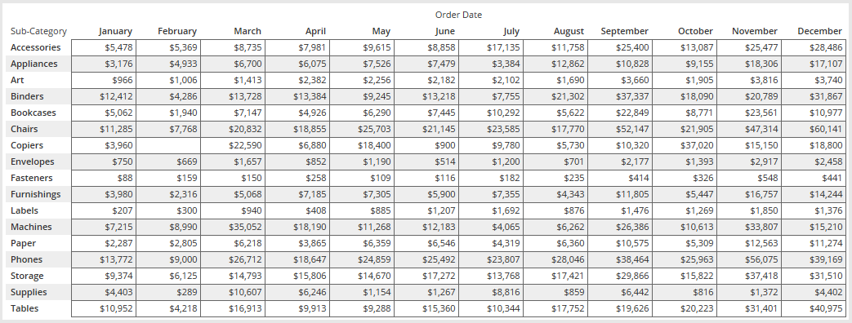

If needed, you can use the darker Backgrounds for borders or row bands, but use these sparingly as they will draw the user’s eye quickly and take attention away from other areas of your viz.

* #333333 (very dark gray)
* #1b5098 (dark blue)

If you add borders to the “Pane,” it will add it to “Headers” as well. Typically, you’ll want to remove the “Header” border, otherwise your table might look a little bit odd…but use your best judgment.

If all you need to do is just deliver some numbers at the end of an analysis or dashboard, then a plain text table is fine. However, crosstabs don’t really give the user any indication of whether something is high or low, up or down, min or max.

This is where highlight tables come in handy. You can add color to either the text or the cell (or both). If you are going to be doing highlighting, it is recommended that you use borders without row-bands, as the additional coloring can get confusing quickly.

Depending on the type of metric you are using, you’ll want to alter your color technique. If you want to compare values, you’ll want to use a continuous (single direction – all positive or negative)

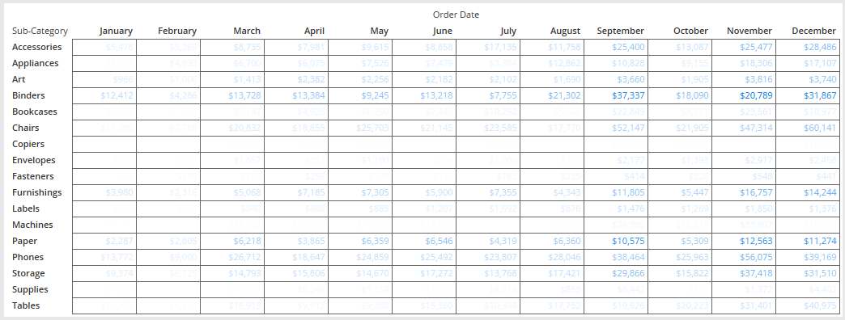

Figure 1 - Sales on Text, Quantity on Color, using Zillow Blue

or a diverging gradient (positive and negative).

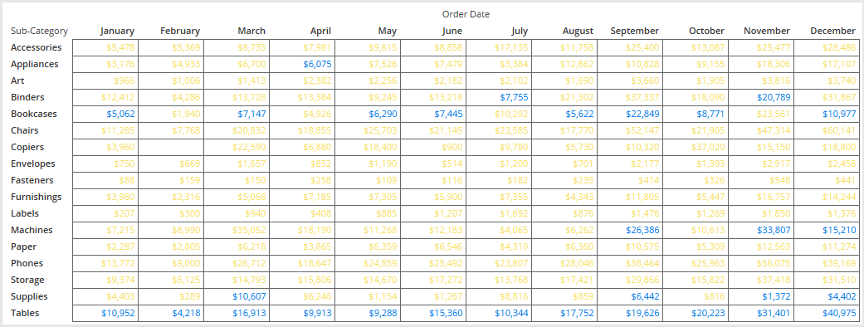

Figure 2 - Sales on Text, Profit Ratio on Color, using Color Blind Palette. Yellow is > 0.

You can also make this a categorical color by using a calculation. This means you are taking a value, [Profit Ratio] and testing whether it’s greater or less than 0.

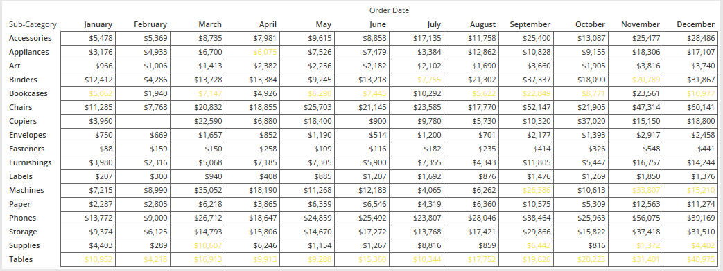

Figure 3 - Sales on Text, Profit Ratio Calc on Color, Yellow is < 0

As you can see, text-based gradients are not all that useful, as they can obscure the actual values. This is where the cell-based highlighting becomes helpful. Tableau can color the background of a cell one color, and you can leave the text alone, making it much easier to read, while making the extremes more obvious to the reader.

One-directional highlighting

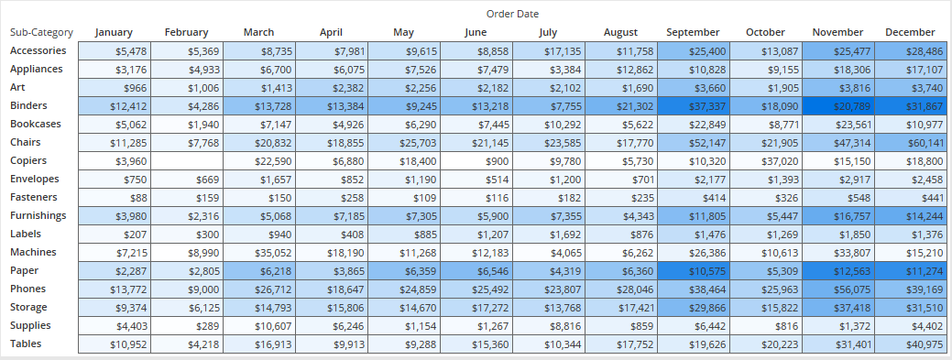

Figure 4 - Sales on Text, Quantity on Color, using Zillow Blue. Mark Type is SQUARE

Diverging highlighting

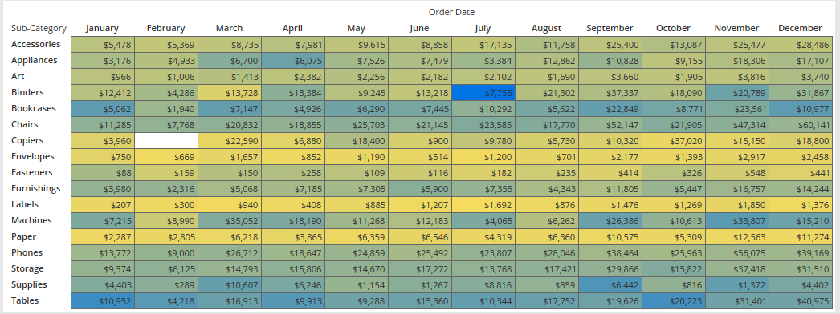

Figure 5 - Sales on Text, Profit Ratio on Color, using Zillow Color-Blind. Mark Type is SQUARE

To achieve binary highlighting on a cell-based highlight table, you’ll need to step your colors, and set it to two (with the center set appropriately). To do this, go to Color Shelf > Edit Color.

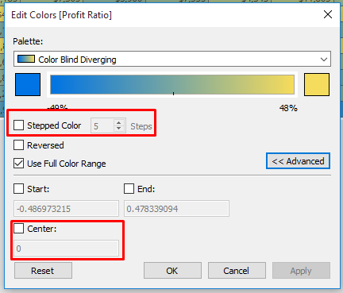

When using highlight tables, you may want to adjust your font and border colors to make the individual cells pop.

Maps – filled and point

Tableau maps are great to show physical location of data. Most of this data will be linked to some sort of geographic information (State, Country, ZIP, Census Block) or latitude/longitude (in decimal). Tableau supports a number of points and shapes out of the box – meaning that if you have a field named “State,” Tableau will interpret that as a State (like WA). The general list is below.

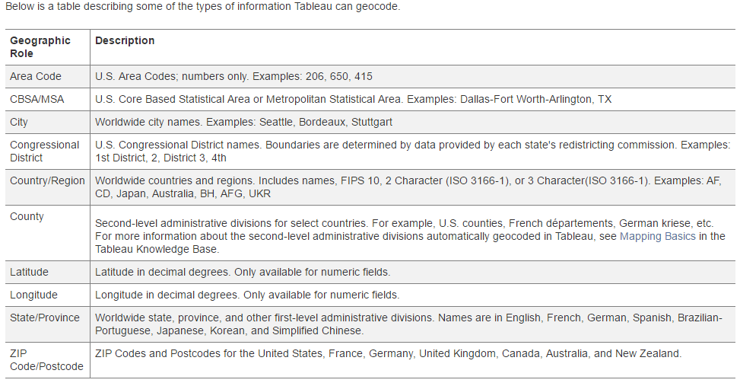

Your data doesn’t necessarily need to be named the same, you can assign data to roles on your own. You can add additional geographies via [this process](http://onlinehelp.tableau.com/current/pro/online/windows/en-us/help.htm#custom_geocoding.html%3FTocPath%3DMaps%7CCustom%2520Geocoding%7C_____0).

For geographic analysis, Tableau supports two types of map: Point and Filled (chloropleth).

For a filled map, you can control the size and color of the points.

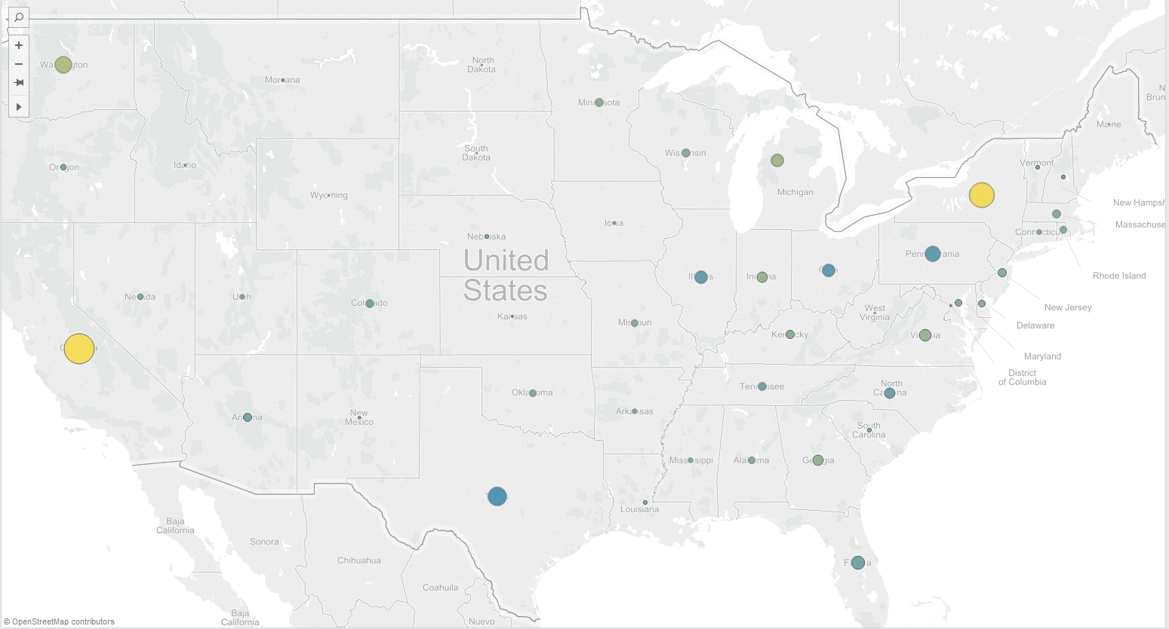

Points for geocoded dimensions are plotted at the centerpoint of that shape, but if you have many dimensions (like three customer categories in a State), Tableau will plot those points on top of each other.

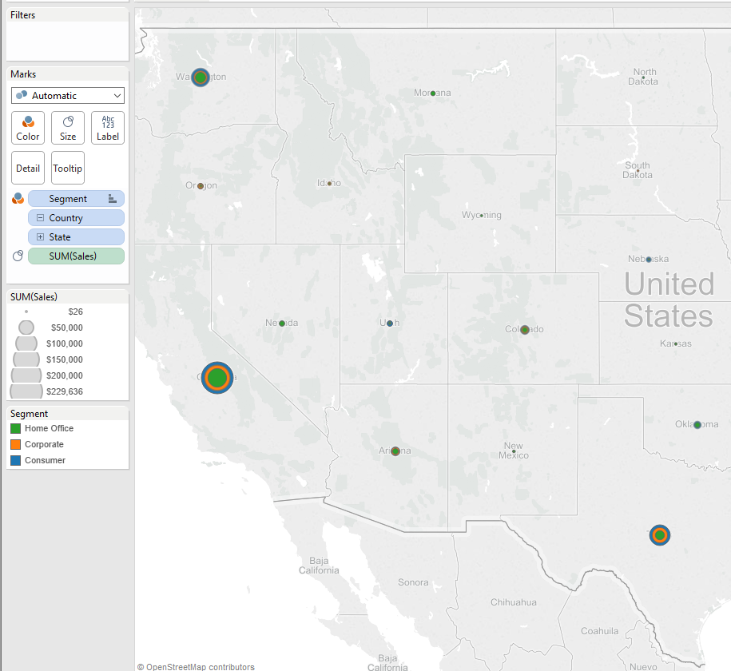

Order of appearance can be manually determined by dragging in the Color Legend, or a computed sort.

Filled (Chloropleth) maps are great for data the spans a specific geography, rather than a specific point. You are only able to control the color of the fill, and with labeling. Something to consider for borders is that the need to be far enough away from the background map in order to show the necessary distinction.

The colors towards the top half of the black/white spectrum tend to work best on Tableau’s standard maps, as the others will blend too much with the “gray map.” Should you be using a satellite map, or something with lots of detail, you’ll want to try colors that are distinct, but not garish.

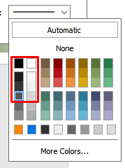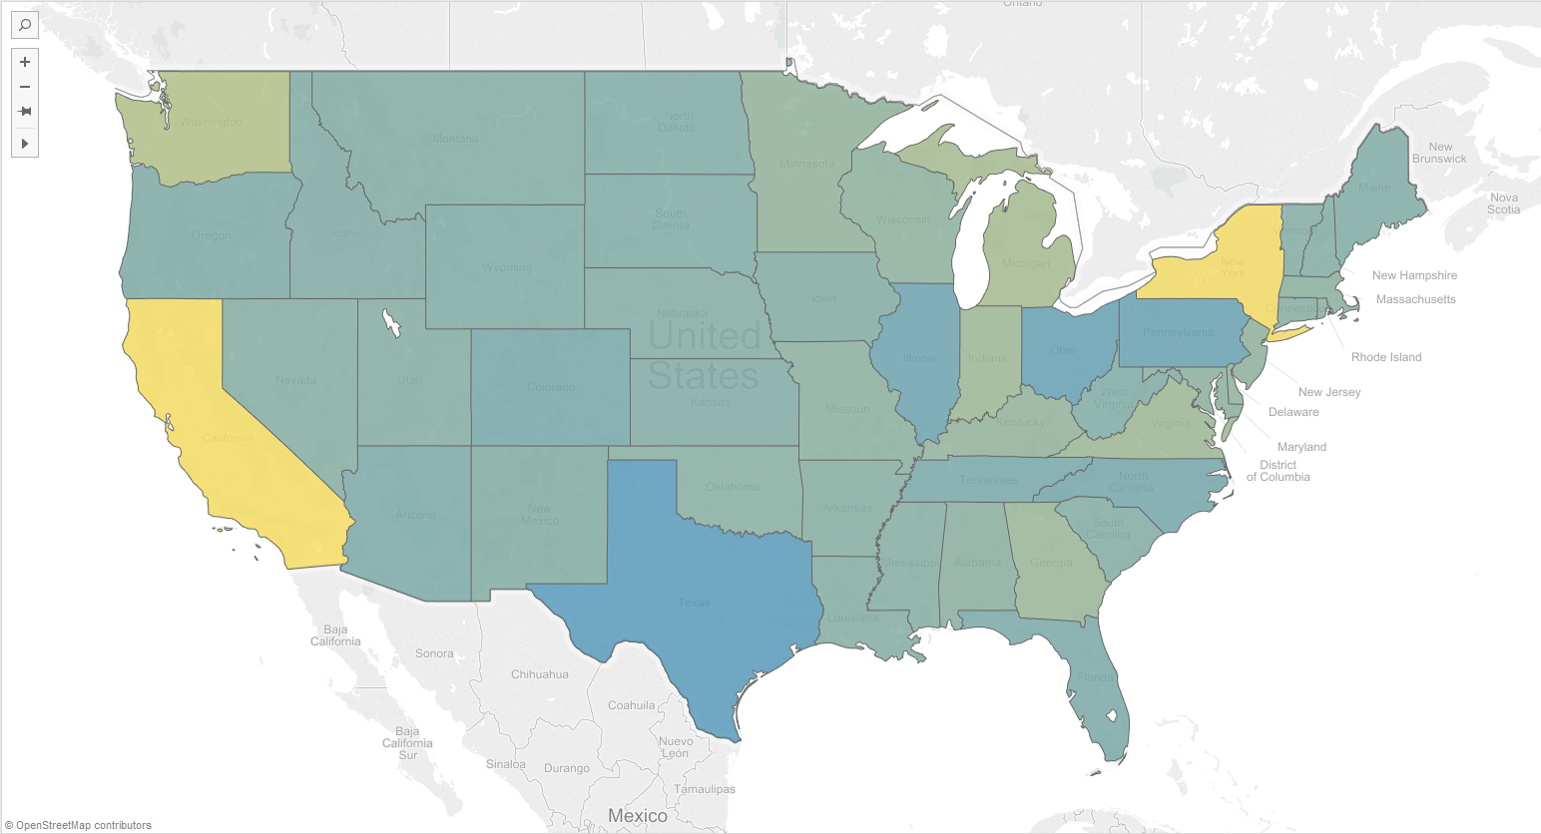

If you decide to use a geographic shape not on a map, you can control the overall size of the shape.

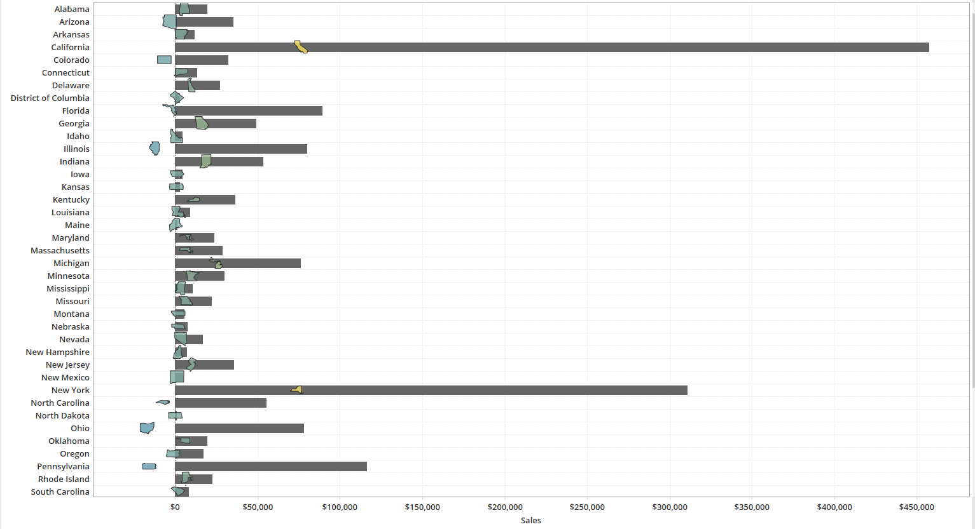

You can also create dual axis maps – with a chloropleth on the bottom and points on top. This is a great choice for showing large aggregates within a geographic region, but also showing distributions within (States and Cities, for example).

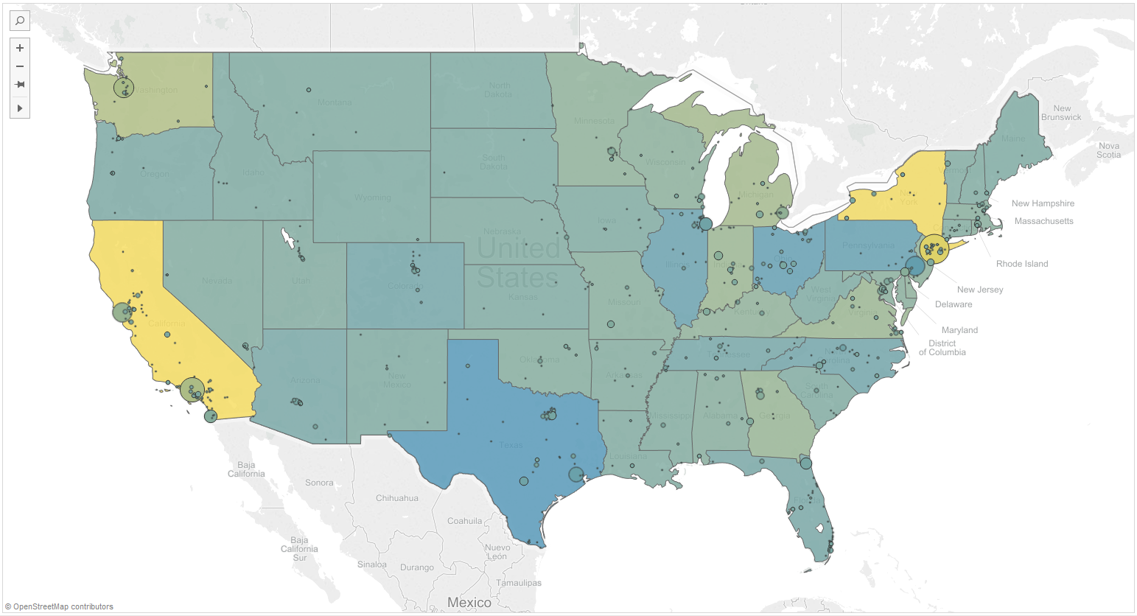

You will need to be careful with this type of chart, as colors can become muddled. This is especially important if your data is high density and you are comparing the same metrics across geographies.

Pie Charts

While often derided by the data visualization community, pie charts do have some utility with part-to-whole comparisons. Humans have a difficult time comparing area and angle, and pie charts do both. Often, the recommendation is to switch to a bar chart – but this does not permit the user to see how much of the whole a given dimension takes up.

For this reason, pie charts should be used sparingly, but if your data or analytic needs meet the following criteria, then feel free to use them.

1. No more than 6 discrete parts – more than 6 will either take up 6 valuable colors or have parts that are simply too small to see (or both).
2. No one slice should take up a majority of the circle. It is not useful to see a slice taking up 75%. Excluding that outlier and breaking out the other dimensions would be more useful.

* Multiple encodings (angle by sales, color by profit) can be confusing – USE WITH CAUTION.
* Labels should be on the outside, for readability.

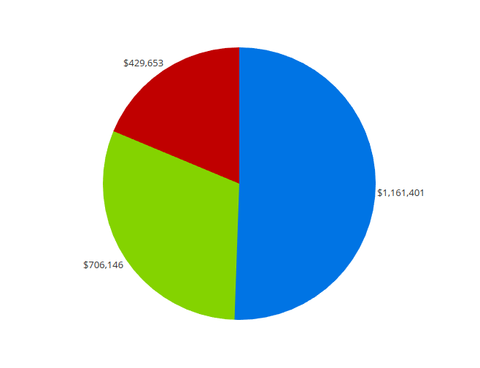

Figure - This is an acceptable, if not wholly informative pie chart.

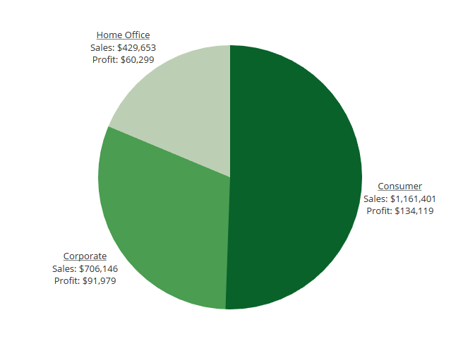

Figure - This pie chart shows two dimensions, Sales on Angle, Profit on Color. Without labels, this is not an understandable chart

Small multiples, resulting in many pie charts, might be useful here, but don’t go overboard.

Bar Charts

Bar charts in Tableau come in three versions:

1. Standard Bar: Useful for comparing values across time (if you don’t want a line chart or across dimensions or combinations of dimensions).
2. Stacked Bar (with a bar-in-bar variant via dual-axis): An alternate method for part to whole analysis, since the dimensions within the bar are actually stacked. Bar-in-bar is useful for target-based analysis.
3. Side-by-Side: Useful for comparing across discrete, related dimensions (like the same month across years).

Choose the type that best fits your needs. The chart should have consistent fonts and font-sizes, with bars in gray or Zillow Blue unless you need to display more measures on a single chart. Borders should be applied around the pane, not on the header.

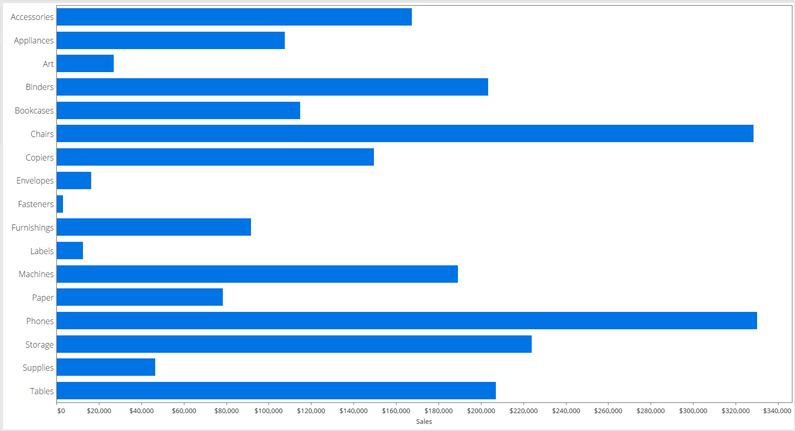

If you want to use a background it is recommend to use a soft color to draw attention to the data pane. This background color can extend into the header if needed, or you can go for a more 538 look by just filling in the pane.

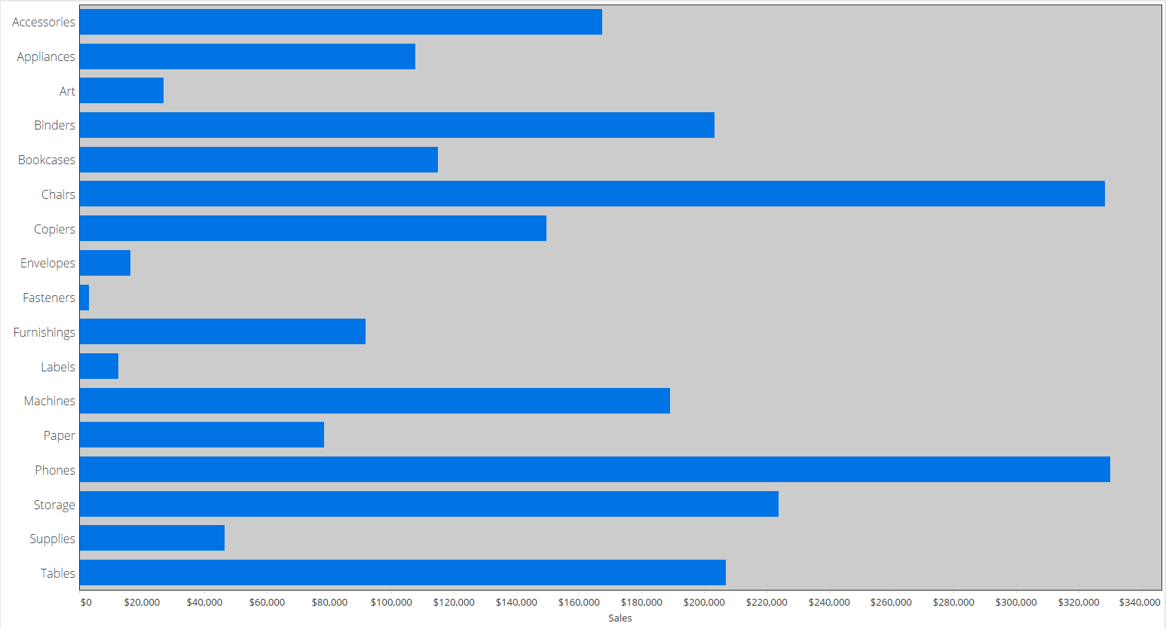

Axes are necessary if you do not label the bars. Once you label more than the min/max, the axis becomes extraneous and should be considered for removal. However, if you are using a non-zero base or a non-linear axis (logarithmic being the most common), you should include the axis.

Stacked and side-by-side bars will require an addition level of formatting via color or size. Stacked bars are the more visually complex, so there is no side-by-side example in this guide. By default, Stacked bars will take each dimensional member and stack them until you reach the whole. 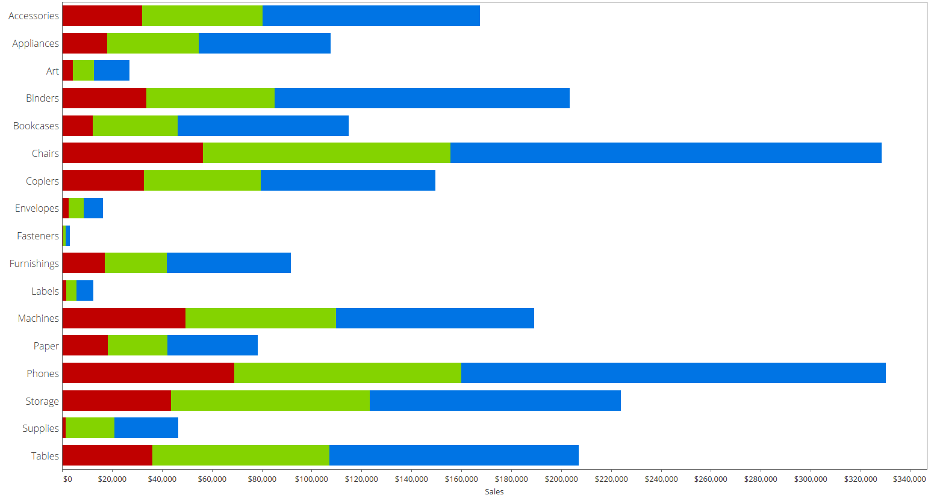

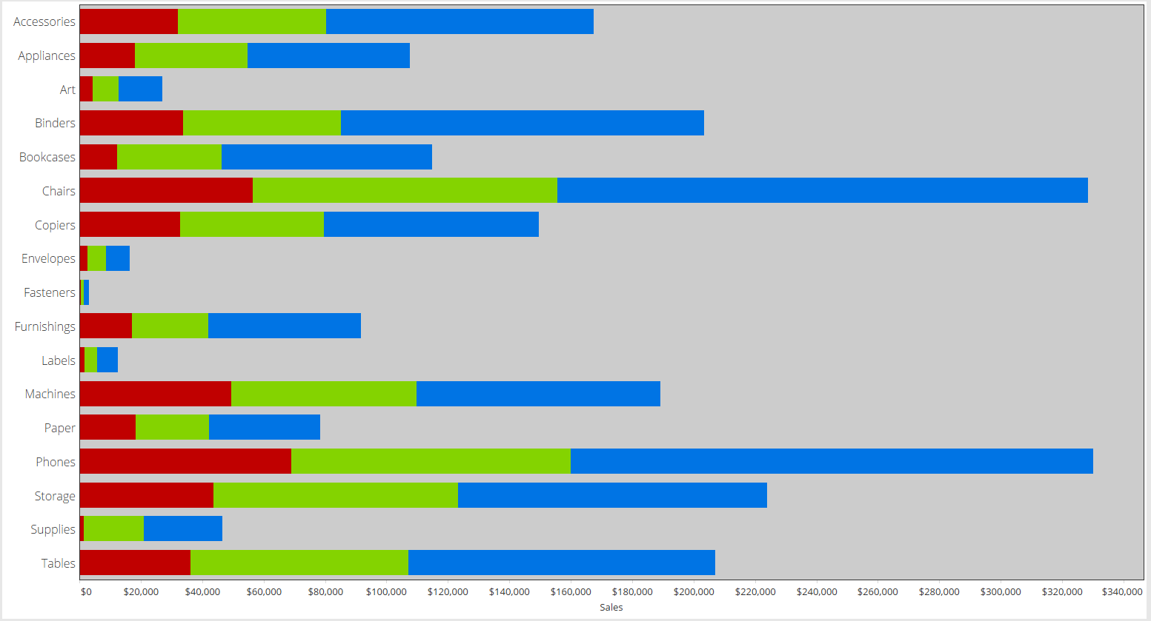

Figure - Stacked Bar Chart

You can also unstack these bars so they each start at zero and are layered. This can create a nested look and easier to compare across multiple dimensions. To un-stack (and this is the same for transforming area charts to horizon charts), go to Analysis > Stack Marks > Off. You will need to resize the bars accordingly, otherwise one dimension will always cover up the others.

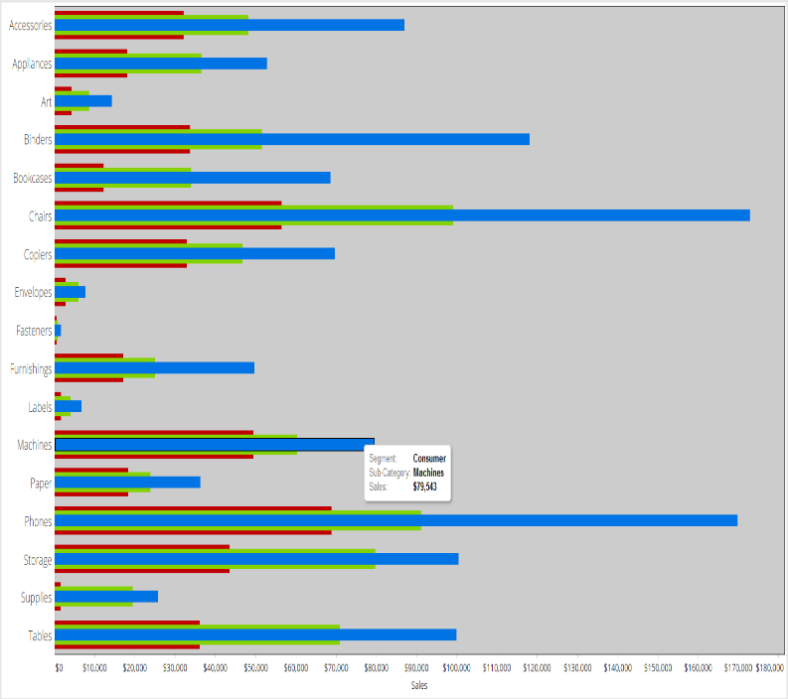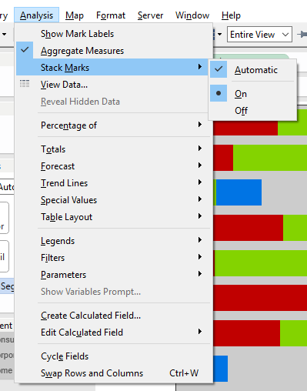

Bubble and Tree Maps

While these aren’t normally viewed as the same type of chart, in Tableau they are only separated by a Mark Type. Both require a dimension and a measure, and function like a pie chart, except in place of slices are circles or squares.

They are best implemented when there is some sort of natural hierarchy that you want to compare across AND within. Think compare all cities to other cities, but also within a state and across states. You get two dimensions to play with, size and color – so you must be careful not to overwhelm the viewer. Size should be the primary measure, and typically color is used to parse out the highest level dimension/category.

For Tree Maps, Tableau will insert white space between the highest level categories, but it recommended to use a border color to more directly separate the boxes. You should also consider removing the Sheet borders as they are redundant at this point.

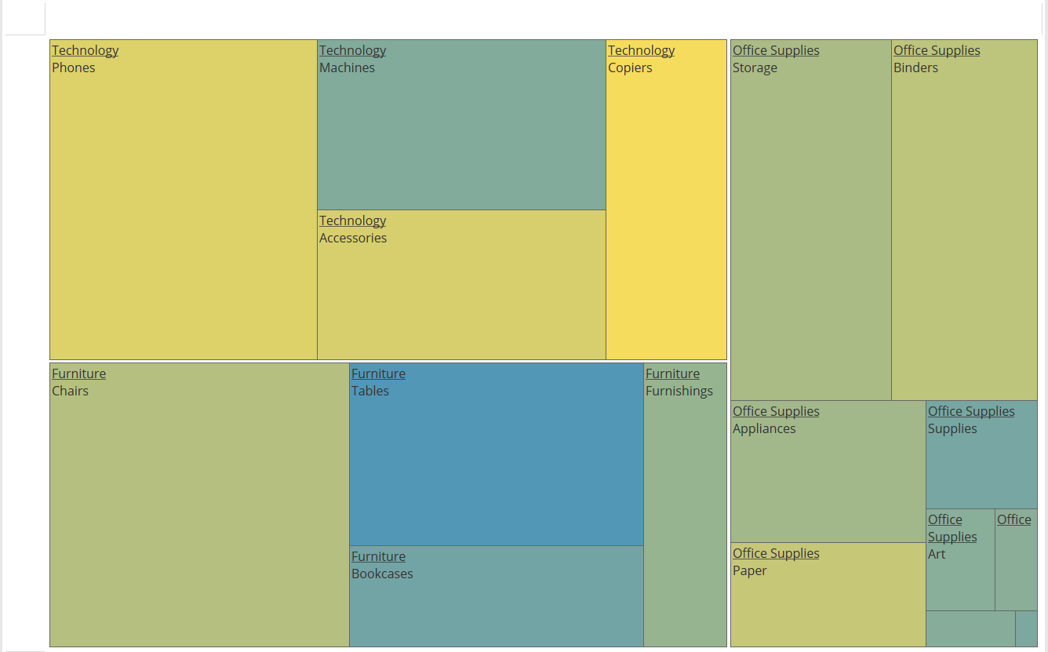

A Bubble Chart is simply the same type of data, just represented as a circle. Tableau will automatically group the bubbles according to the dimensions in the Level of Detail.

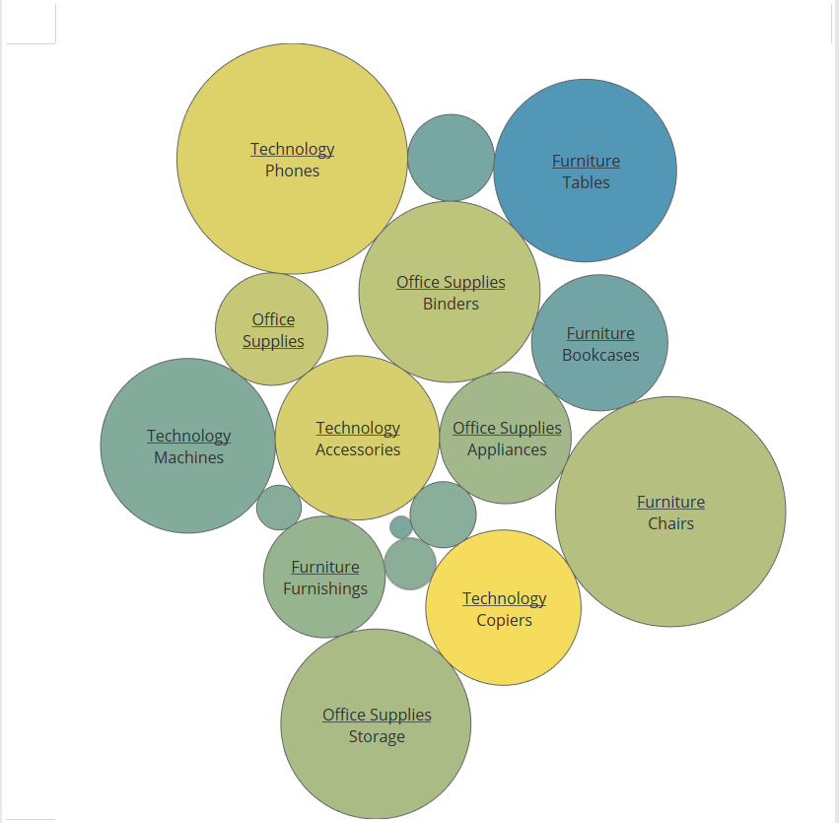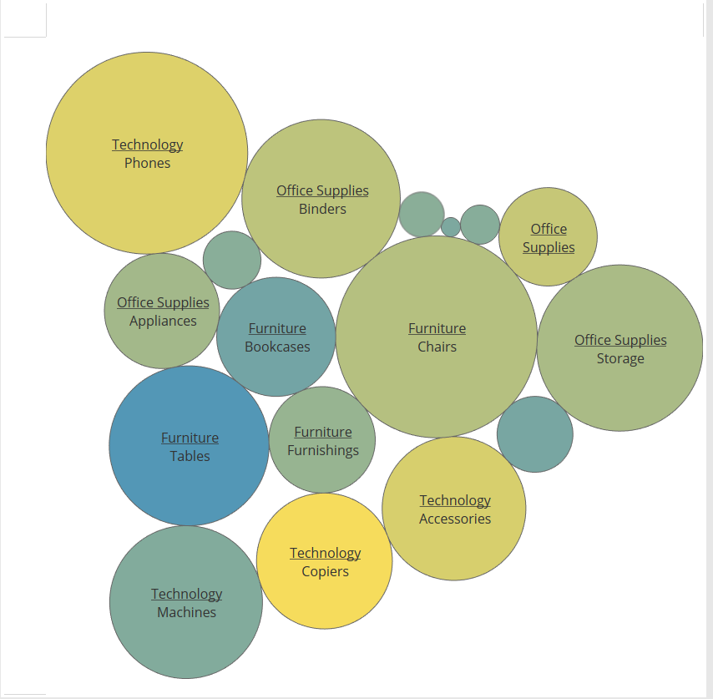

Figure - Bubble Chart with Sub-Category in the highest LOD

Figure - Bubble Chart with Category in the highest LOD

For both Tree Maps and Bubble Charts, relative areas are hard to judge, and labels are a necessity. Dense data can be a great eye catcher when used [appropriately](http://blog.gdeltproject.org/tableau-iron-viz-2015-optimism-vs-pessimism-in-news-sources/), but these should be used with forethought.

Line and Area Charts

Line charts and area charts are related like bar charts and stacked bar charts. The only difference is that area charts fill under the line and stack by default. Both are great for showing trends and relative positions over a continuous dimension (like time). In addition to the standard dimensions, measures, and marks you have control over the path of the line via the path shelf. This allows you to force the line to move in a specified direction – such as closing a polygon.

Many of the same guidance for bar charts apply to line charts. Gray lines for single dimensions, and colors for categories, with a soft background color to provide distinction. You can also control the width of the lines based on additional dimensions, but this should be used with caution so as not to dwarf the other lines (if you have outliers or one dimension is overweight vs the others).

Grid lines are helpful to guide the users to distinct intersections, and should be as thin as possible. The color should be close to the background color so as not to be a distraction.

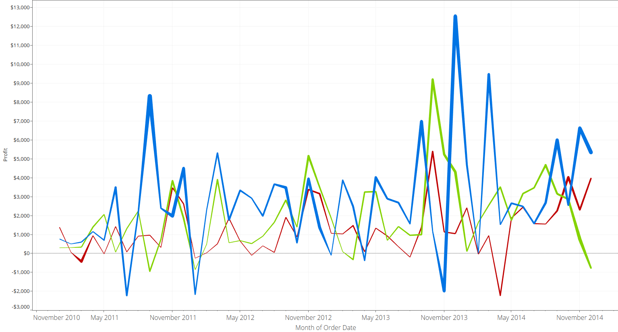

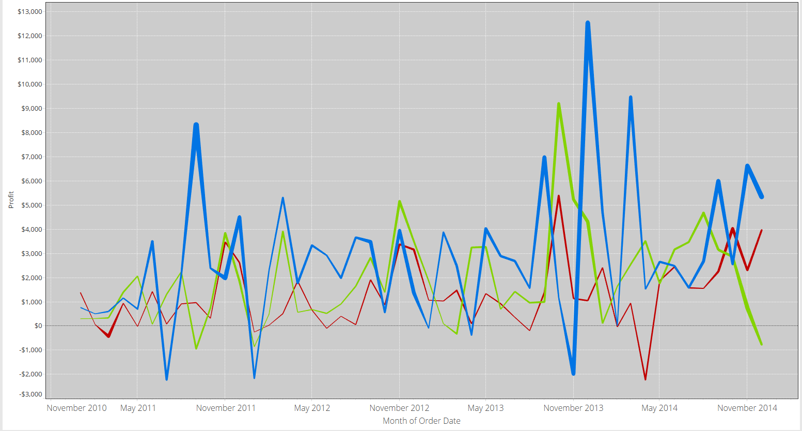

Area charts will stack by default, so they can be misleading if you simply change the chart type via the Marks card. This is the same chart as above, just as AREA. 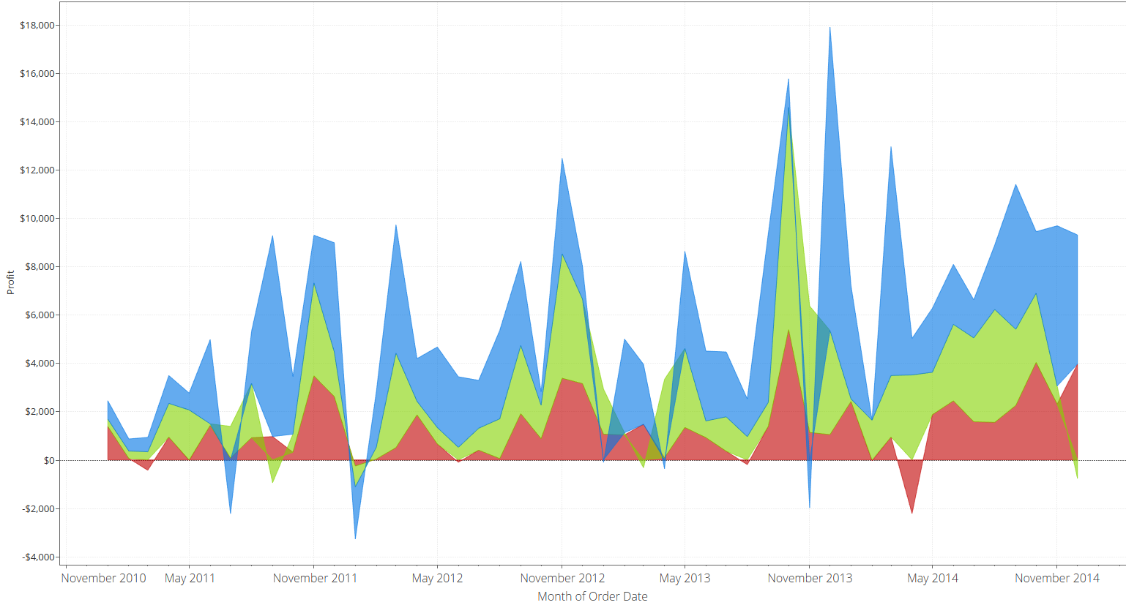

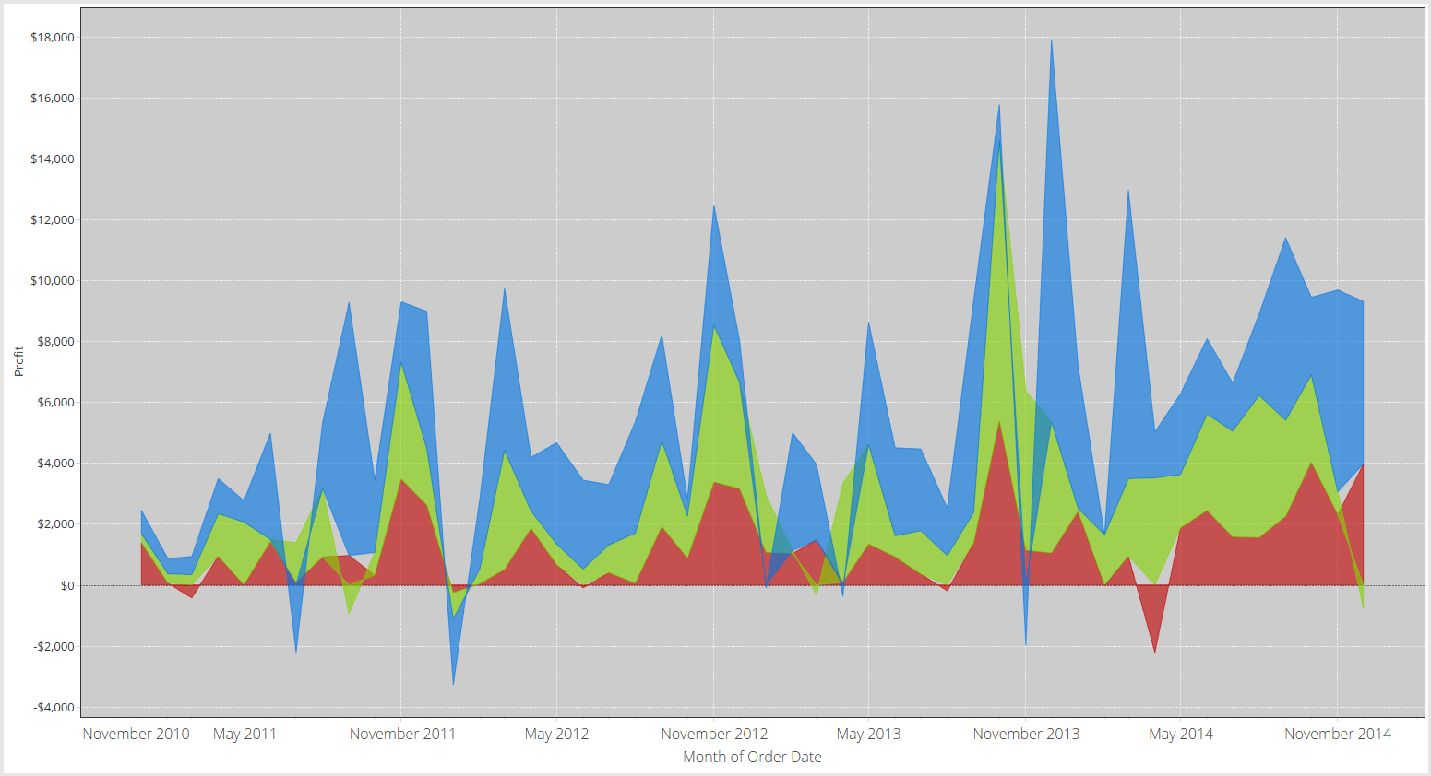

Visually, this is best practice, but notice the last negative point on the right, just before May 2014. The red point is correct, but the blue mark is just above the green mark, where before it was below. This is due to stacking of the points. To correct for this, you need to turn off Stacking, just like in the bar chart example. Below is the new chart

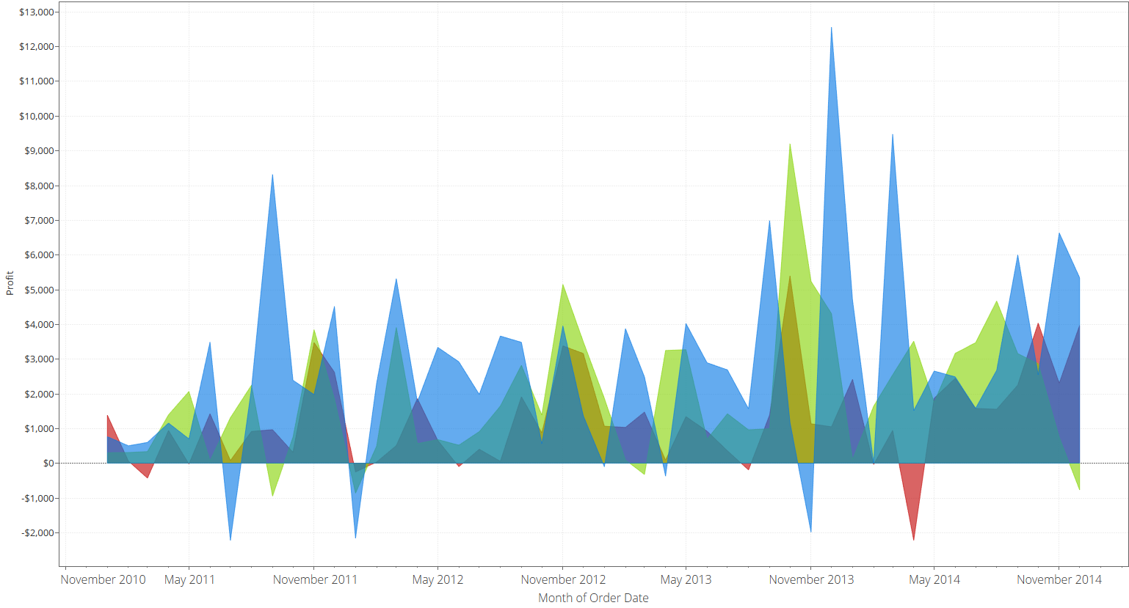

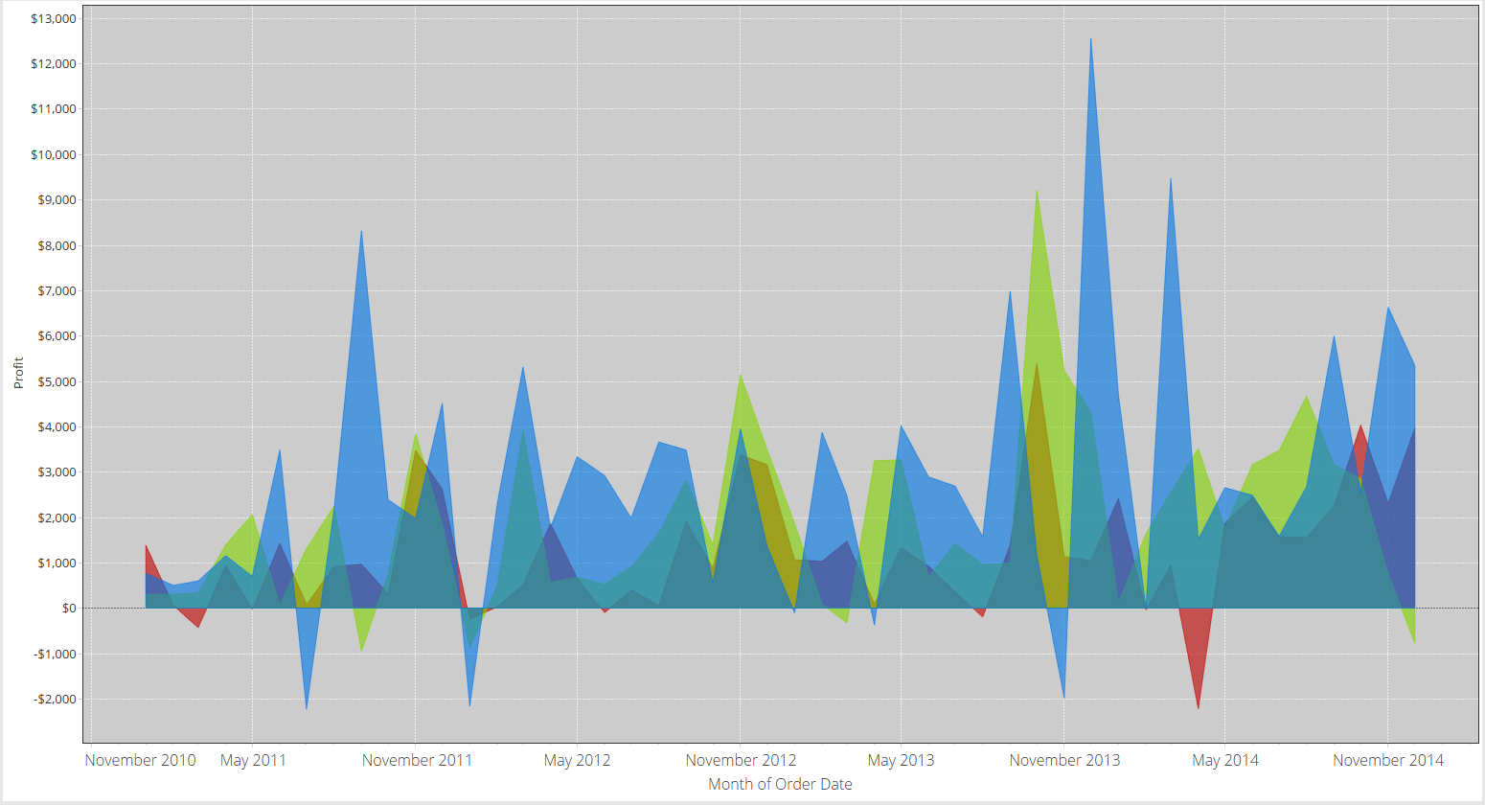

You’ll notice that the areas are now the same as the lines, but they are in front of each other. This order can be adjusted via sorting.

Scatter Plots

These are very useful tools for displaying dense and highly dimensional data. In addition to the measures on Columns and Rows, you also get size and color encodings, with the option for shape-level encoding. This gives you the ability to show up to 5 dimensions of data simultaneously. As a rule of thumb, the more dimensions you include, the greater the opportunity for misunderstanding. To help, one should use the following guidance:

1. Is position sufficient? (This is default dimensions)
2. If no, then encode on size. The eye is drawn to higher weighted items, with size = weight.
3. If you need more, then encode on color. Use as simple of a color scheme as possible. Gradients will work better than categories as gradients carry weight better than discrete colors.
4. If you absolutely need more, then encode on shape. These shapes should be simple and either directly related to the dimension (like male/female shapes) or an actual icon for a company or service.

Filled shapes tend to look better than open shapes, but you can use your best judgment.

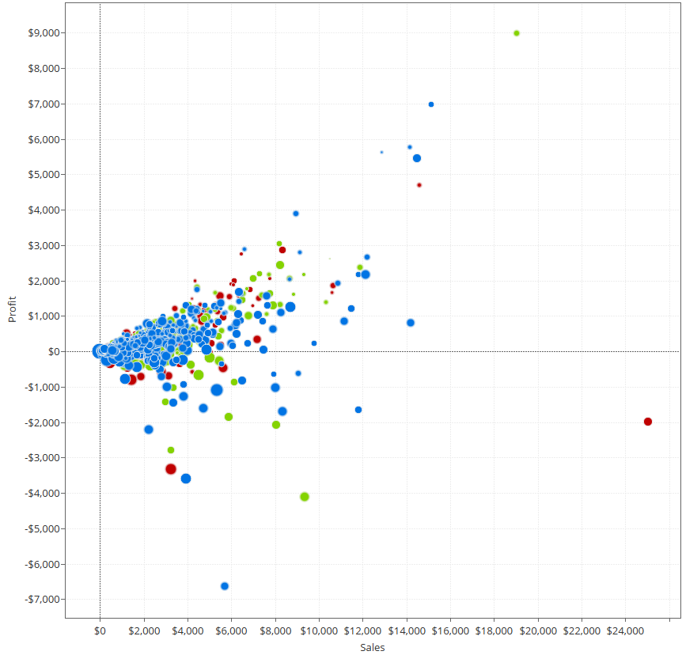

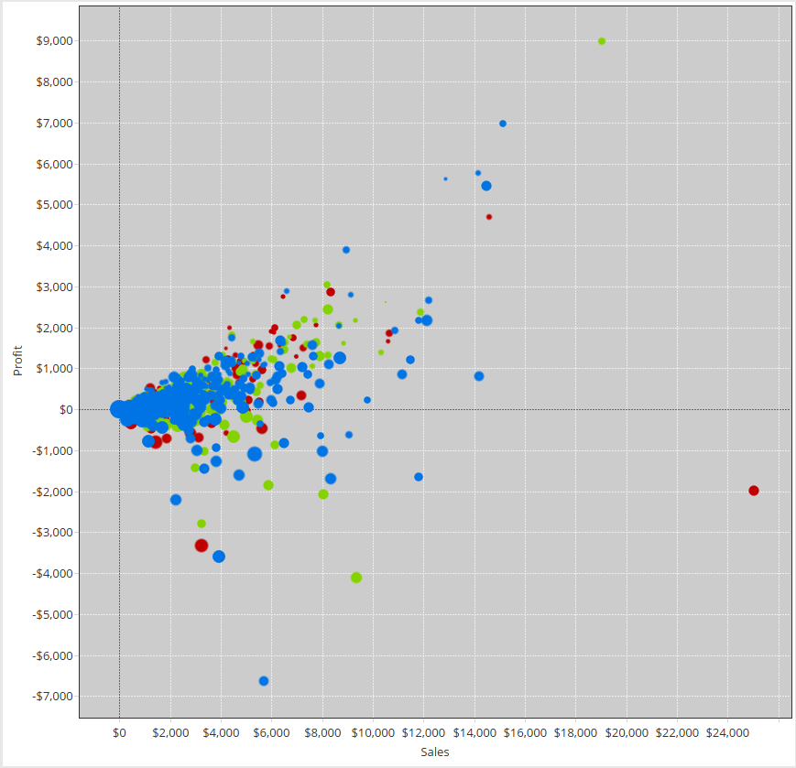

In this example, you’ll notice that there are some large clusters towards the origin. In this case, it is hard to tell how many points are there. To combat this, you can use a combination of transparency (to see through the points) and borders (to denote individual points). You’ll have to play around with the settings, as both transparency and borders will interact together and with the background color. Typically 65-75% transparency is sufficient, although lower values can yield very interesting looking charts. You may also have to adjust the background color to your own taste.

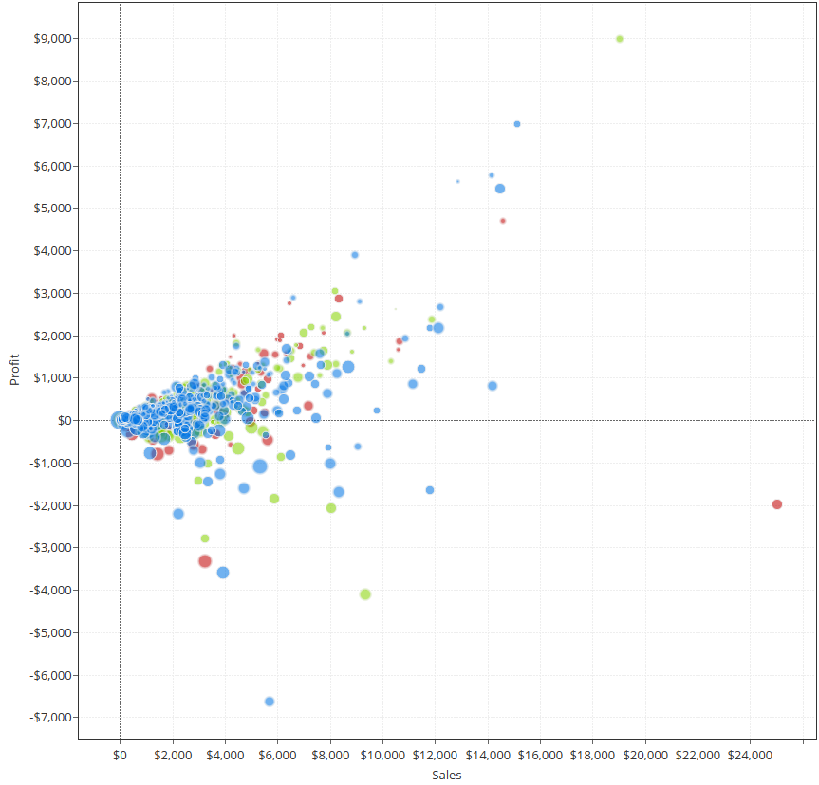

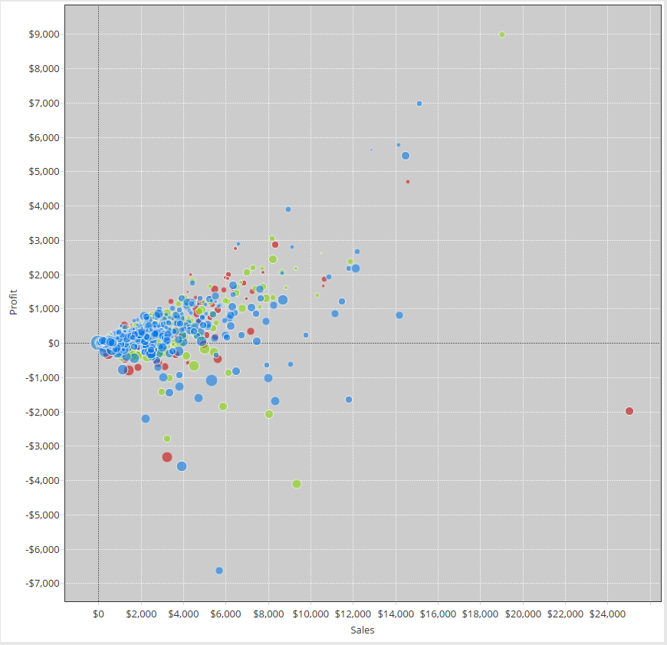

In this case, a simple border would have been sufficient as transparency drowns out the smaller points near the top.

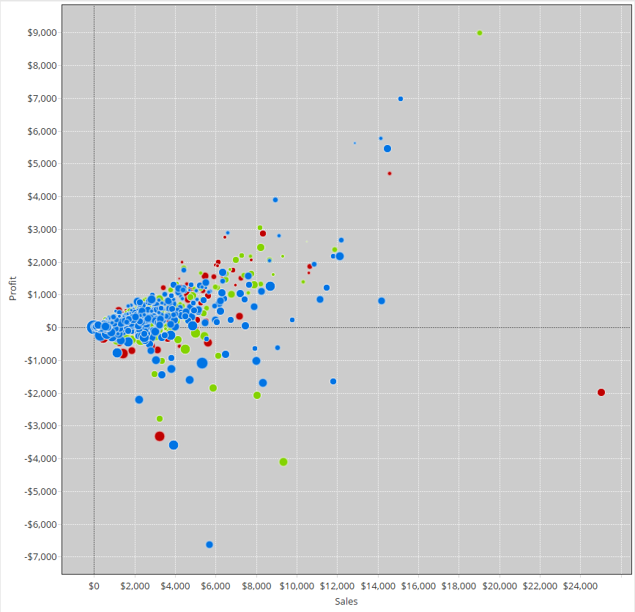

Box and Whisker

These are great for showing distributions across dimensions. They are essentially bar charts, but with circles for every mark at the level of detail you choose. Standard box-and-whisker plots, with lots of supporting data, can be hard to read due to mark stacking. 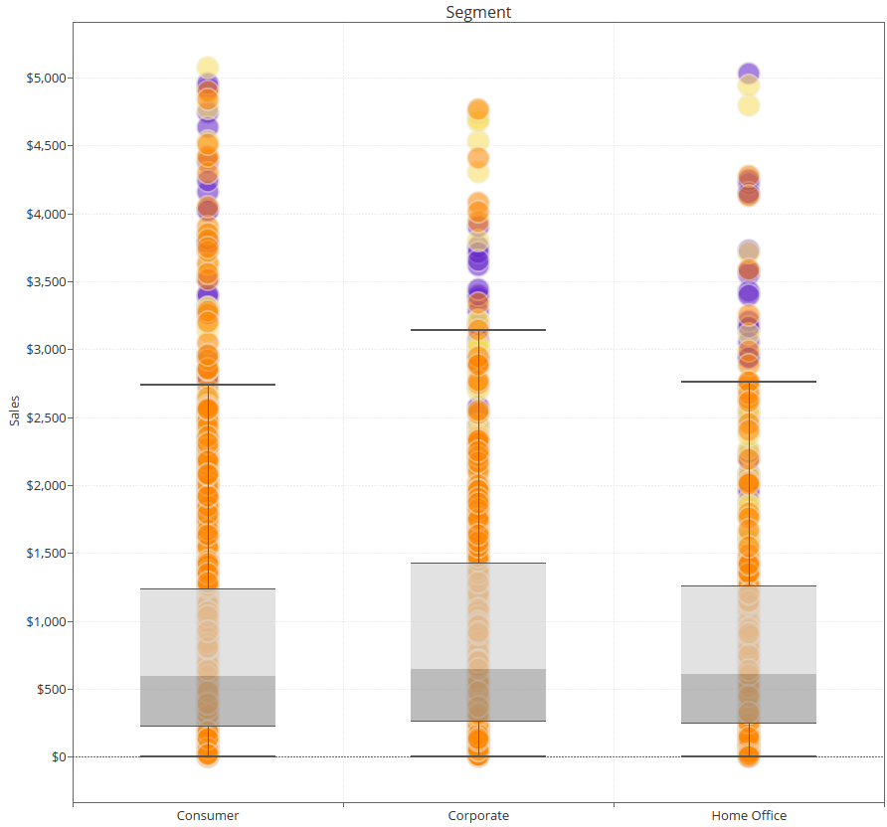

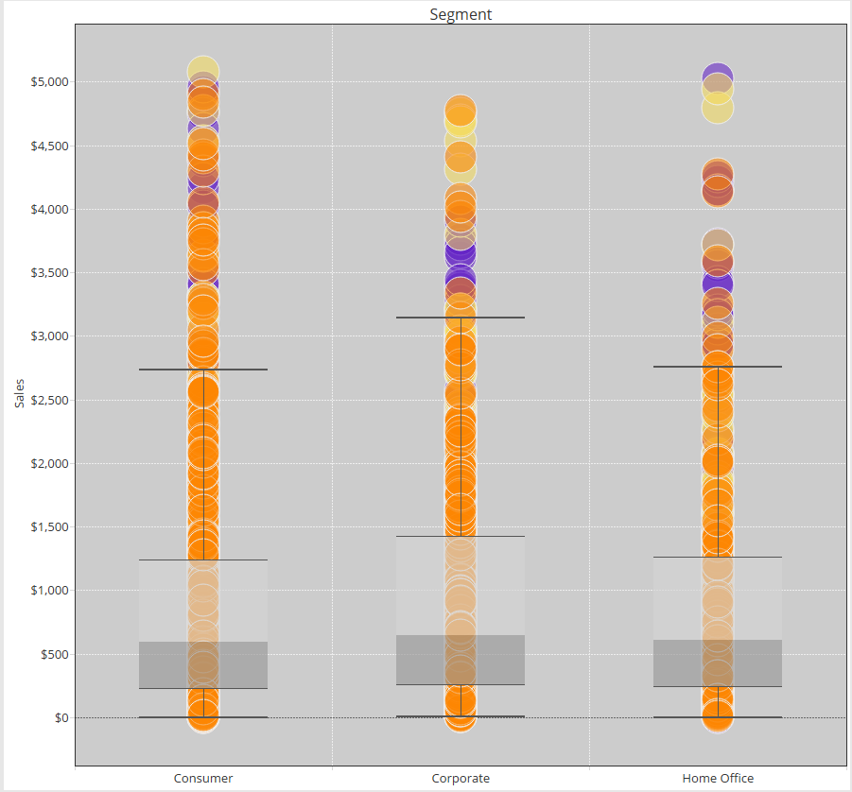

In this case, it is often best to jitter the points (moving them left and right a random amount) so as to see the actual distribution. To accomplish this, you need an additional calculation, computed at the lowest level of granularity:

***Jitter = index()%25***

This is a Table Calculation that should be calculated at the level of “Customer Name” (or the lowest level of detail). This will spread out the points and create a new dimension, which you will need to hide once you are done. 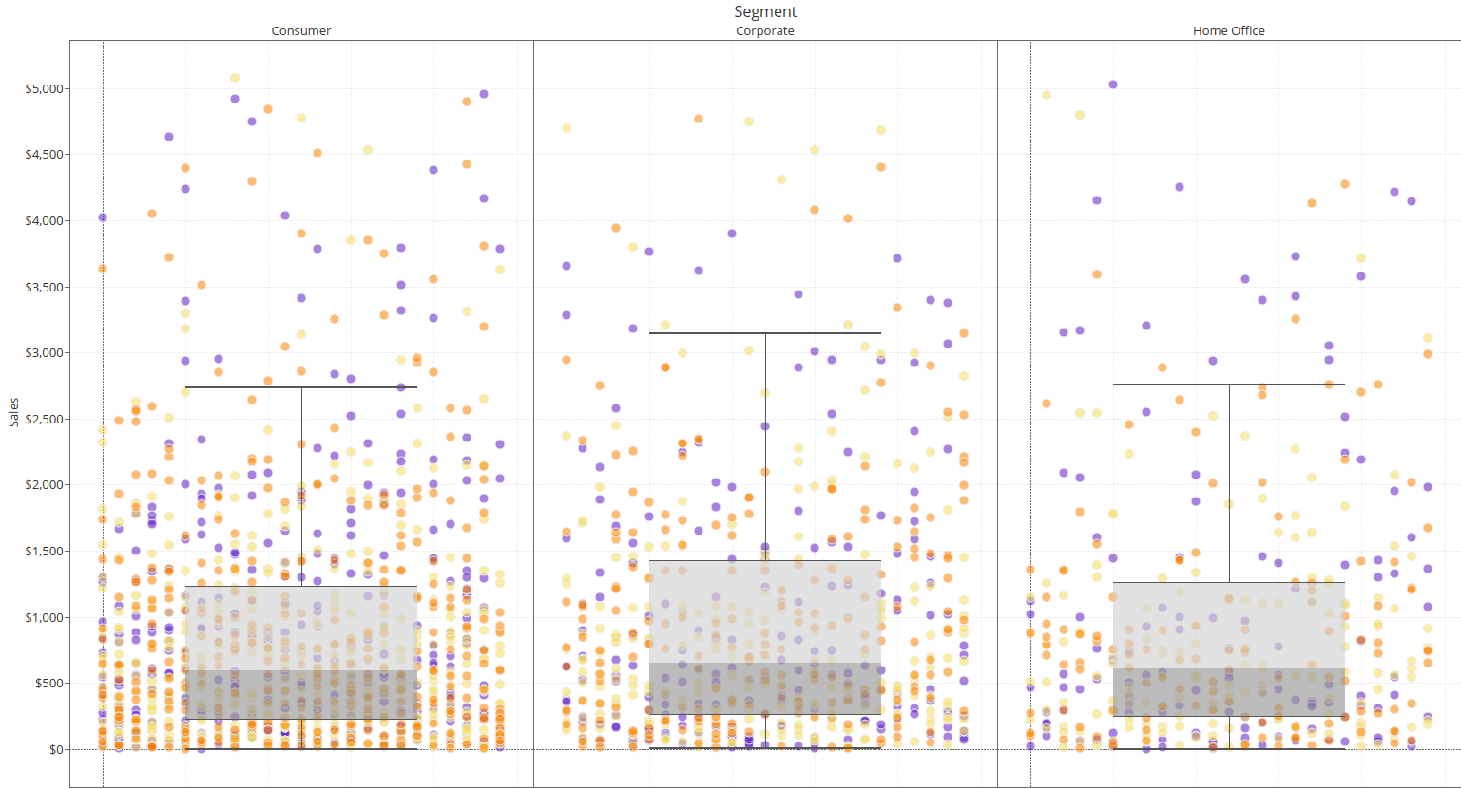

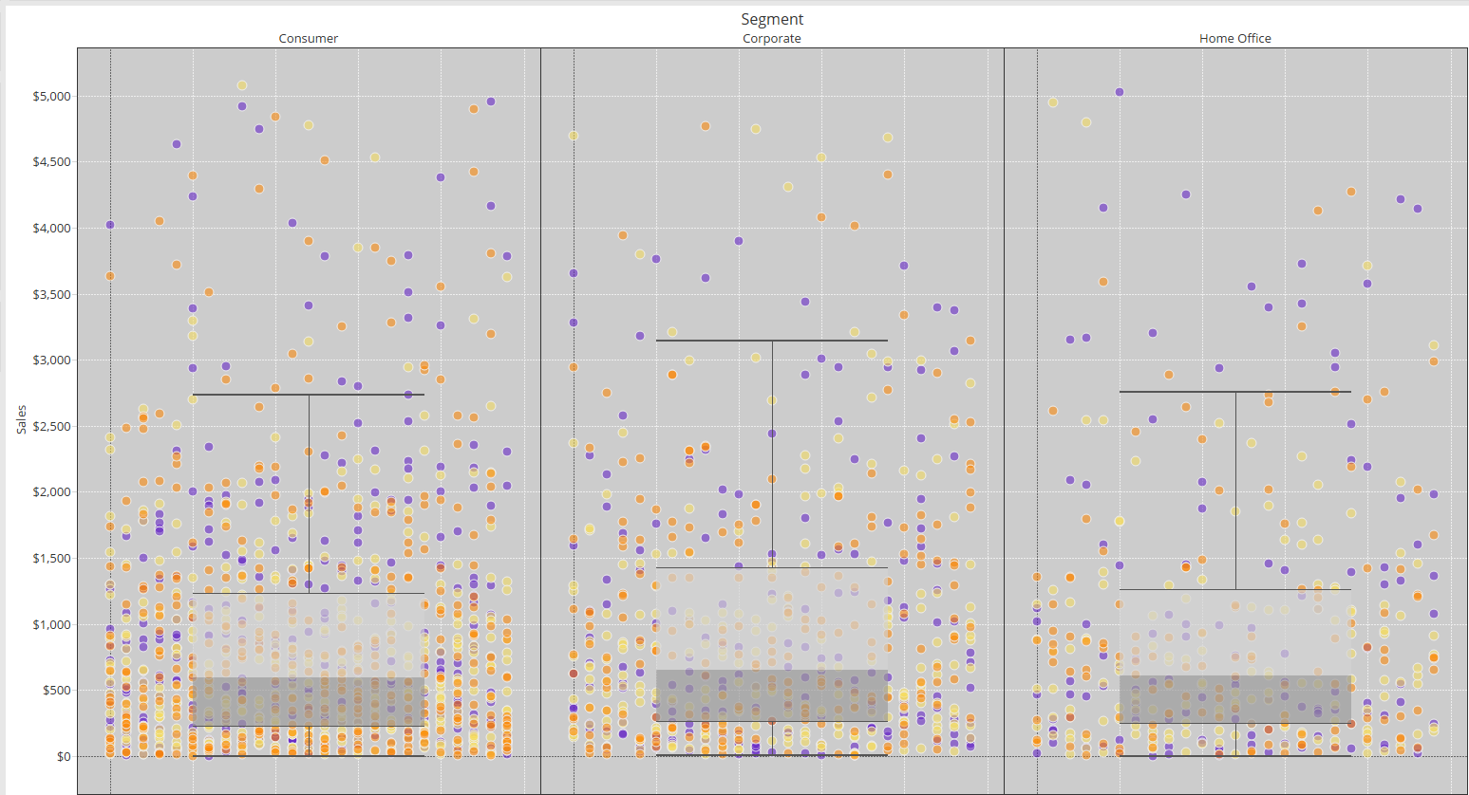

Gantt Chart

Gantt charts have typically been used to track time and duration of activities. The Gantt bar is also a good substitute for circles in a box and whisker plot since it is a single line. Typically, a Gantt requires a set of activities or steps that run sequentially (and may or may not be dependent), with as start and end time so duration can be computed.

In Tableau, the lowest level duration that can be displayed is a day, so any value less than a day must be converted into a day via a calculation.

The other use case is to calculate multiple durations across a single dimension (like customer) and the chart can show where long or short durations are present. 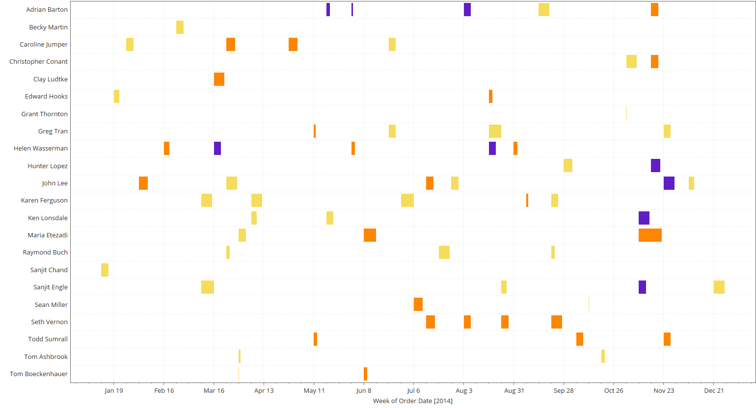

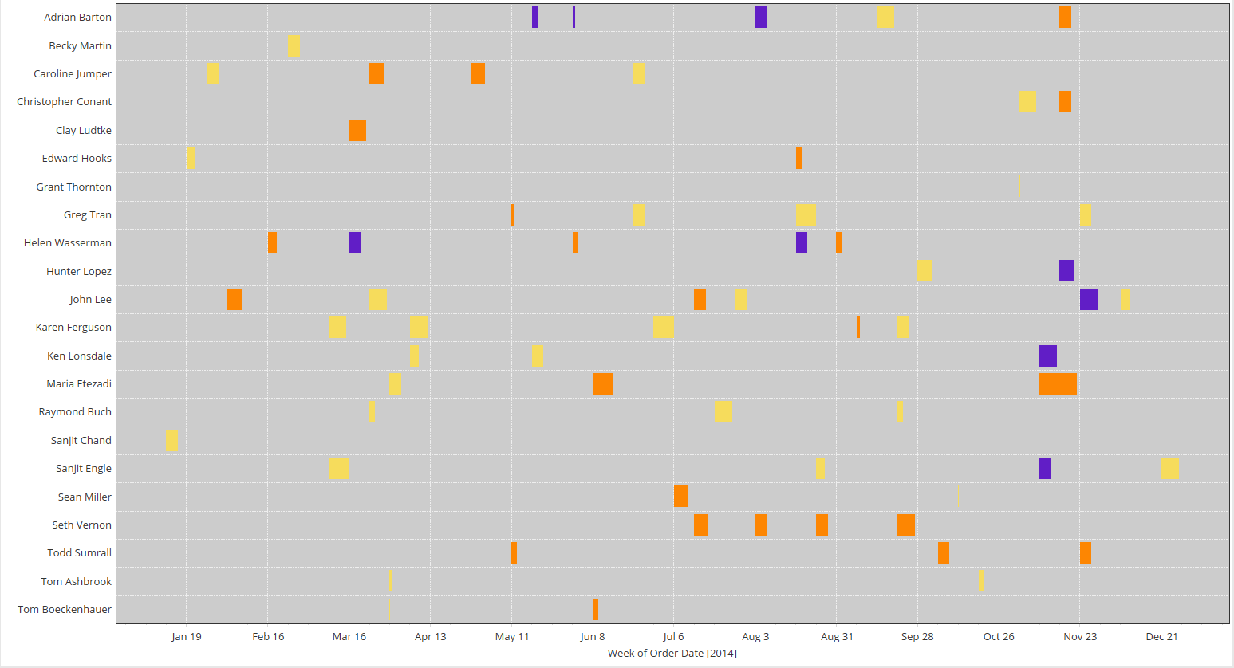

Bullet Chart

The Bullet Chart is Tableau’s version of a gauge – it is intended to show marginal progress towards a goal, at discrete intervals. These can be user driven or computed goals. Adding extra borders can improve your ability to distinguish across the dimensions. If you do add additional borders, you should also consider increasing the weight of your overall target line, so it doesn’t look like a border.

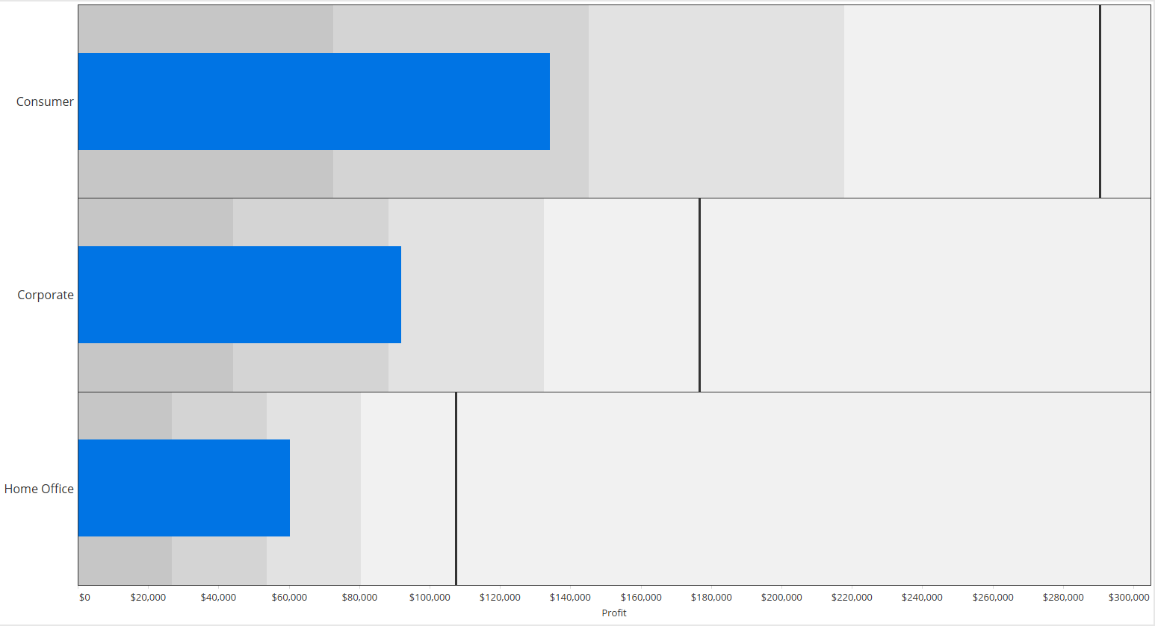

Finally, bullet charts are an excellent opportunity for conditional formatting. Creating a calculation that tests the progress is much easier than manually guessing, especially as the value approaches the target. This will help the viewer quickly determine how close to target the value is without really having to look closely.

